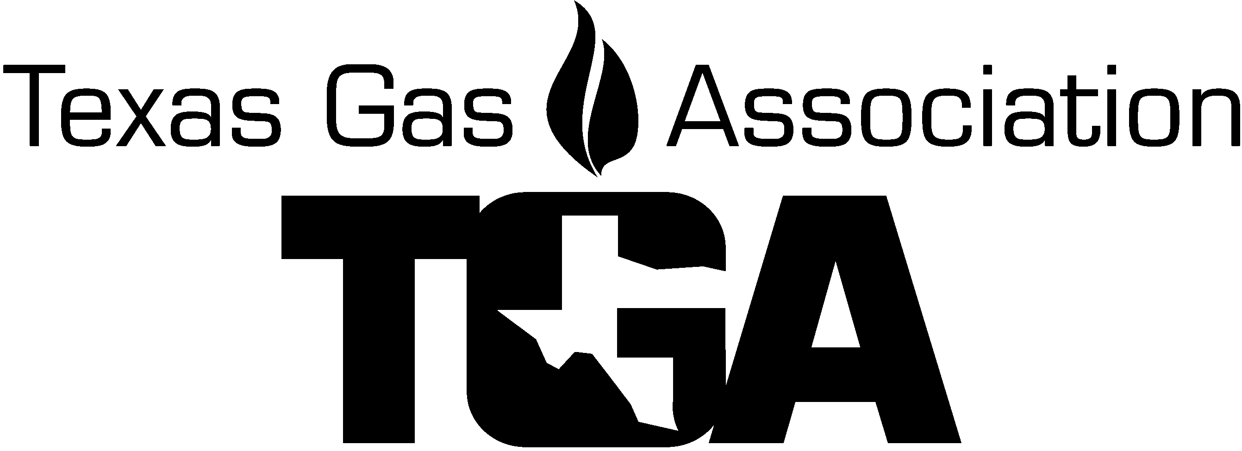
2023 TGA Damage Prevention & Safety Roundtable
Registration Materials

Join us for the 2023 Damage Prevention and Safety Roundtable! The roundtable this year is in Plano, Texas.
Atmos Energy will host the event at the Charles K. Vaughan Center, 3697 Mapleshade in Plano, TX. 75075. The roundtable will provide information for all damage prevention and safety professionals and any other gas company employees. This gathering of the best minds in the industry encourages discussions on the current state and federal regulations and allows for the face-to-face exchange of information and ideas on industry best practices, and what works and what doesn’t.

Meeting Agenda

(Subject to Change)
Wednesday, August 16th
7:30 - 8:00 am Exhibit setup
8:00 - 9:00 am Exhibits Open
8:00 - 8:45 am Registration & Continental Breakfast
8:45 - 9:00 am “Welcome & Introductions” (Committee Officers)
9:00 - 9:50 am “Opening Remarks by Committee Chairs” – Ketha Molina and Greg Wise
9:50 - 10:40 am “Near Misses on the Work Site” – OSHA
10:40 -10:45 am Product Showcase Presentations
10:45 -11:35 am “Collapsible Shoring Equipment” – Groebner
11:35 - 12:00 pm Exhibits Open
12:00 - 1:00 pm “Sponsored Lunch” – Thank you Atmos Energy
1:00 - 1:50 pm “Pre-excavation Checklist/Damage Investigation” – Derrell Isenberg, Binkley & Barfield & Atmos Energy
1:50 - 2:40 pm “Second-Party Damages”
2:40 - 2:45 pm Product Showcase Presentations
2:45 - 3:00 pm Refreshment Break & Exhibits Open
3:00 - 4:30 pm “Active Shooter” – Gary Henderson, Retired Texas Ranger
4:30 pm Meeting Closed
6:00 pm Dinner – Location TBA

Thursday, August 17th
8:00 - 9:00 am Exhibits Open
8:00 - 9:00 am Continental Breakfast
9:00 - 9:50 am “Leak Demonstration” – Atmos Energy
9:50 - 10:00 am Exhibits Open / Product Showcase
10:00 - 11:00 am “The Science of Fire Retardation” – Bulwark, Derek Sang
11:00 End of Meeting
After the Meeting ends Atmos will host a tour of Gas City for those wanting to stay after the meeting

Topics I would like to discuss:

Topic ___________________________________________________________________________________
Question ______________________________________________________________________________________________________
________________________________________________________________________________________

The Final Registration date for the Roundtable is Friday, August 4th, 3:30 PM

Please see the list of hotels near the Charles K. Vaugh Center

2023 TGA Damage Prevention & Safety Roundtable

REGISTRATION FORM

(Please, One Registrant on each form)

Company ________ Attendee Name ________________________________

Co. Address ____________________ City, State, Zip -

Phone _____________________________ Cell Phone ______________________________
E-mail: ______________________________________________ Spouse’s Name (if attending) _____________________

Registration | Amount | Price
TGA Member Attendee Registration | $245.00
Non-TGA Member Attendee Registration | $295.00
Spouse’s Lunch & Dinner
Spouses Dinner | $70.00
Exhibit Tabletop & Additional Exhibitors
TGA Member Tabletop – includes 1 person | $350.00
Non-TGA Member Tabletop – includes 1 person | $400.00
TGA Member Additional Exhibit Personnel | $245.00
Non-TGA Member Additional Exhibit Personnel | $295.00
Final Registration date for the R/T is August 4
TOTAL DUE
Please answer the questions below. Will you be attending?
- Wednesday’s Lunch? Yes or No
- Wednesday’s Dinner? Yes or No

Check payable to TGA enclosed □ Charge my ______AMX, ______Master card, or ___ Visa

Credit Card # _________ __________ __________ __________ Exp. date _______ Sec Code ______ (AMX 4 digits)

CC Billing Address _____________________________________________ City, St, Zip code ________________________

Name on card ____________________________

E-mail for receipt: __________________________________________, Name _________________PH# ________________

Cancellation for Roundtable Seminar must be in writing. Cancellations 30 days plus prior to seminar: Full refund less $30.00 processing fee. Cancellations 11-29 days prior to the conference: Refund half of Seminar event charges. Cancellations less than 10 days prior to the conference: will not be refunded. No-shows: will not be refunded. Substitute Attendees will be accepted.

