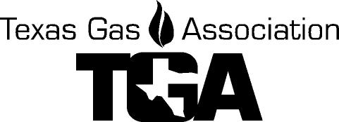
Damage Investigation

Pipeline Damage Investigation Class
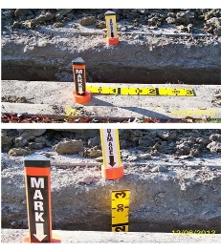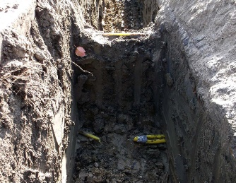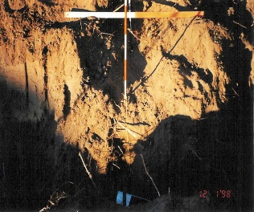
Brenham, Texas
Wednesday, October 18, 2023
9:00 a.m. to 3:30 p.m.
Review and perform a hands-on investigation of a simulated pipeline damage incident. Review your results and determine if your investigation was sufficient to protect your company from fines resulting from Chapter 18 violations from the Railroad Commission.
Instructor: Ande Bostain with the City of Brenham will lead the class, coordinating several vendors and contractors making presentations on the need for and proper way of documenting a damage scene. Also participating will be members of the TGA Safety Committee to watch for safety violations and participants from Texas811 to assist in the hands-on portion of the class.
Where: Fireman’s Training Center, 1101 Highway 290 W, Brenham, Texas 77833
Fee: $50 for members, $85 for non-members, Includes lunch
Return this class registration form with payment to the TGA Office by:
e-mail to mail@texasgas.com or postal mail to PO Box 420960, Houston, TX 77242-0960
Registrant(s) ____________________________________________________________

Company ___________________________________________

Address ____________________________________City, ST, ZIP _________________

Phone ____________________

For Check request - Person to receive an invoice:

Name: ____________________________ Email: __________________________

All card information is required for processing.

Credit Card # ______ ______ ______ _____ Exp. Date ________ Sec Code _____

CC Billing Address: ___________________________ City, St, Zip __________

Name on Card ____________________

E-mail for receipt_________________________, Name ____________ PH# ____________

For more information, call Linda Femal or Darrell Cherry at (281) 497- TGAS (8427)
Cancellations received 5 days or more prior to the class date are eligible to receive a refund less a $10.00 processing fee or have the full dollar value kept as a credit on the TGA account to be used by the end of the calendar year. Cancellations received less than 5 days before the event day are not refundable.
Substitute Attendees will be accepted for the class.

