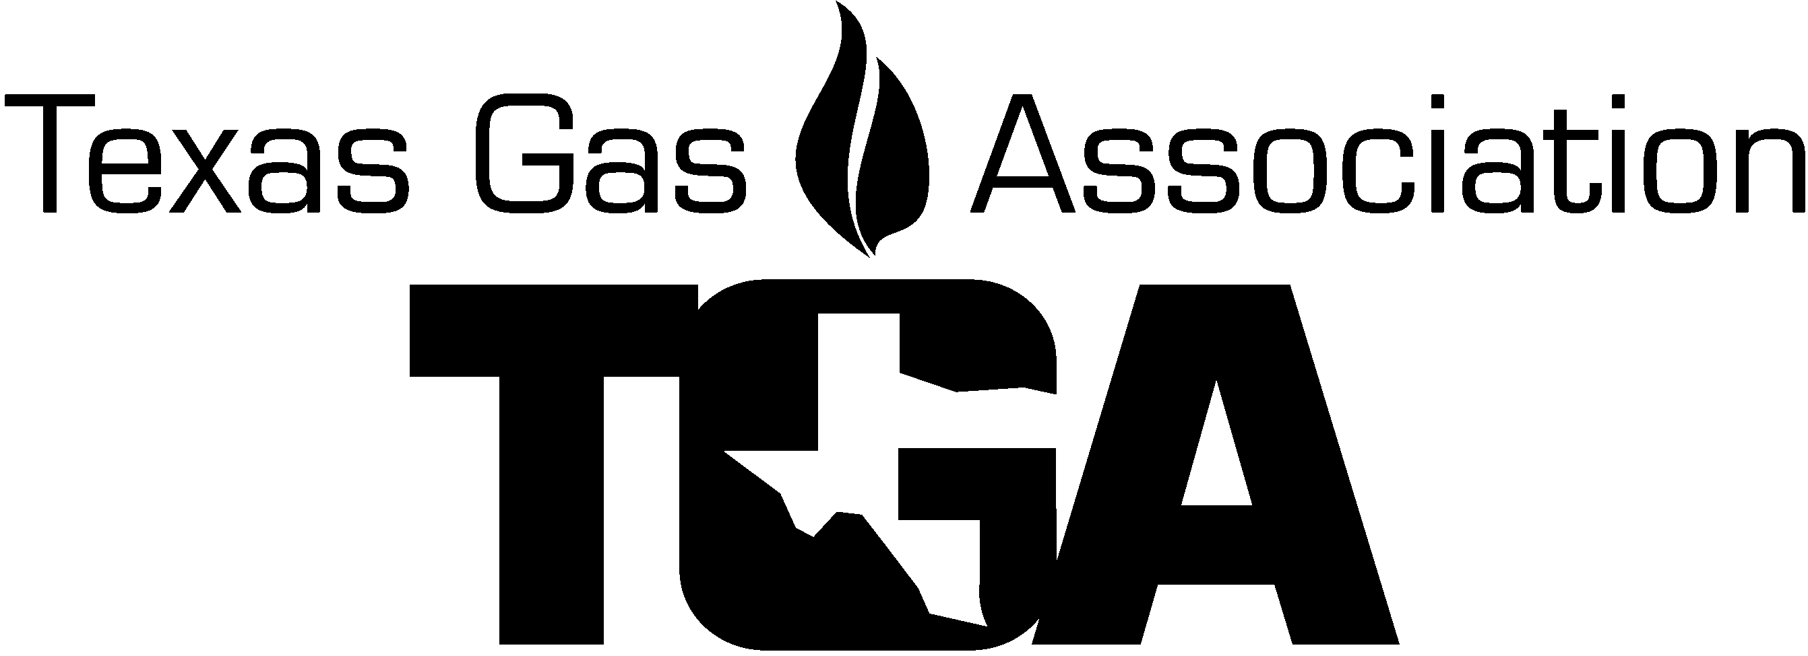
DATE: March 14, 2023

TO: TGA Officers, Board Members, Advisory Council, Committee’s and interested parties.
FROM: Paul Kennedy, Chairman of the Board

RE: Spring Board Meeting, April 21, 2023

Please join us for the 2023 Spring quarterly meeting of the TGA Board of Directors and Committee meetings that will be held April 21, 2023, at New Braunfels Civic Center located at 375 S. Castell Ave., New Braunfels, TX 78130.

Hotel Information:
Arrange for your hotels on your own.

List of some hotels in the area:
Hilton Garden Inn (free breakfast)
1501 N Interstate 35 Frontage Rd, New Braunfels, TX ﻿78130
(830) 620-4200
Hampton Inn & Suites (free breakfast)
575 Hwy 46 W South, New Braunfels, TX 78130
Call - (830) 608-0123
Court Yard By Marriott ($ Breakfast)
750 I-35 North, New Braunfels, TX 78130•(830) 626-4700
Country Inn & Suites (free breakfast)
La Quinta Inn & Suites (free breakfast)
Wingate (free breakfast)
Comfort Inn & Suites (free breakfast)
Best Western (free breakfast)
Holiday Inn Express (free breakfast)
Homewood Suites (free breakfast)
Resort at Schlitterbahn (no breakfast)

Google hotels near New Braunfels Civic Center for a huge listing of hotels.

Complete the TGA Registration form and return it to the TGA office.

Committee Chairs

- Be prepared to report to the Board of Directors on Friday following lunch.

- Please e-mail your committee members this invitation for the quarterly event today.
- Schedule your meetings for Friday, April 21, 2023 – beginning at 8:45 am.
  - The Scholarship Board and Committee will meet 9:00 – 10:00 AM – Annual meeting will follow..

Board Meetings Cancelation Policy: Effective January 15, 2009
Golf: Cancellations received 11 days or more prior to the Golf Outing date are eligible to receive a refund less a $10.00 processing fee or have the full amount as a credit on the TGA account to be used by the end of the calendar year. Cancellation received less than 11 days are not refundable.

Dinner: Cancellations received 5 business days or more prior to the Dinner Outing date are eligible to receive a refund less a $10.00 processing fee or have the full amount as a credit on the TGA account to be used by the end of the calendar year. Cancellations received less than 5 days are not refundable.
Substitute Attendees will be accepted for all events.

TGA Spring Board & Committee Meeting Registration Form
Civic Center, New Braunfels, TX - April 21, 2023

(One Meeting Attendee per form)

Company_____________________________ Attendee Name_______________________________

Co. Address _____________________________ City, St., Zip _______________________

Cell # ________________ Office # _______________ Spouse’s Name ____________________
(No registration fee required if attending Dinner only)
E-mail ____________________________________

- Meeting Attendees: mark your calendar and return this form with payment, to the TGA no later than Monday, April 10, 2023.

Golf – No formal golf outing has been set up, but the Bandit Golf Course is nearby, and Wednesday would be a great day for a game. Phone: (830) 609-4665

Dinner at Krause’s – 6:30 pm – 9:00 pm

Dinner is at an additional cost; Will you be attending dinner at Krause’s? …. YES or NO
Will you attend the Committee Meetings? ……………………... YES or NO
Lunch is included; Will you be eating lunch with us? ……….…….. YES or NO
Will you attend the Board of Directors Meeting? ……….…….. YES or NO

Meeting Attendee Registration per person – $125.00 X 1 = $125.00
(Includes lunch for registrant)

Dinner at Krause’s Thursday night 6:30PM $79.00 ea. X #____ = $______
If attending dinner, please complete the selection form below.

Extra Lunch for spouse/guest - $45.00 ea. X #____ = $______
Spouse / Guest Name (s) ______________________, _______________________

TOTAL AMOUNT DUE TGA = $__________

E-mail this registration form, with your payment information, to:
E-mail: mail@texasgas.com or Linda.femal@texasgas.com

Mail Check to PO Box 420960, Houston, TX 77242-0960. Make payable to TGA
Check enclosed Or Bill to my AMX MasterCard Visa

Credit Card # ______ ______ ______ _____Exp. Date ________ Sec Code _____ (AMX 4 dig. On front)

CC Billing Address: ___________________________ City, St, Zip __________

Name on Card ____________________

E-mail for receipt_______________________________, Name ____________ PH# ____________

If attending dinner, please complete selection form below.

Spring Meeting Agenda:

Thursday, April 20, 2023

Arrive at Hotel (s)

6:30 – 9:00 PM - Dinner at Krause’s

Friday, April 21, 2023

8:30 AM Morning Break – Coffee, Pastries, Snacks *& Beverages – Garden Room

8:45 AM – 11:15 AM Committee Meetings begin – Garden Room
Scholarship followed by Annual Meeting
Associates Meeting
Distribution Meeting
Distribution Sub-Comm Advancements Leak Detection Meeting
Damage Prevention & Public Awareness Meeting
Safety Meeting
Employee Development Meeting
Marketing & Communications Meeting
Transmission Meeting

Friday, April 21, 2023

11:30 AM – 12:30 PM Lunch Buffet Served - Garden Room

Friday, April 21, 2023

12:40 PM – 3:00 PM – Board of Directors Meeting

3:00 PM Adjourn

