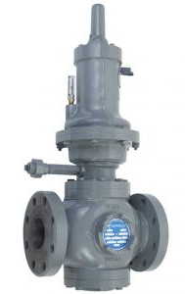
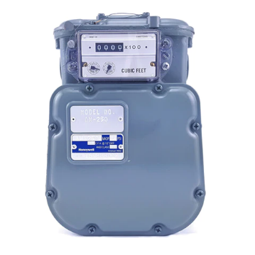
Measurement & Regulator Basics

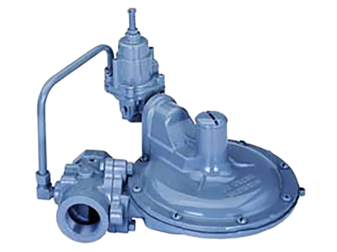
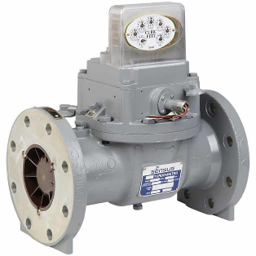
Measurement & Regulator Basics

Tomball, Texas

Tuesday, May 16, 2023
9:00 a.m. to 3:00 p.m.

The session covers the fundamentals of natural gas measurement & regulators. This class will help students better understand natural gas flow mechanics and the gas laws that affect metering and pressure reduction. Topics that will be addressed include, but are not limited to meter setups, regulator concepts, diaphragm meters, rotary meters, turbine meters and ultrasonic meters.

Instructor: Travis Eiermann, FMP, SFP with Equipment Controls Company (ECCO)
The TGA is proud to have Mr. Travis Eiermann with ECCO as our subject matter expert presenting this important topic. Mr. Eiermann is valued by many of our gas operator members, especially our municipal operators, for his knowledge and insight. He is versed in the installation, maintenance, and operation of these types of facilities and brings to the industry a background in facilities management.

Where: City of Tomball Auditorium, 501 James St, Tomball, TX 77375
Fee: TGA Members - $50 per person. Non-members - $85 per person. Lunch included!
**Return this class registration form with payment to the TGA Office
E-mail to mail@texasgas.com or by US Mail to PO Box 420960, Houston, TX 77242-0960

Registrant(s) ____________________________________________________________

Company ___________________________________________

Address ____________________________________City, ST, ZIP _________________

Phone ____________________

For Check request - Person to receive invoice:

Name: ____________________________ Email: __________________________

All card information is required for processing.
Credit Card # ______ ______ ______ _____ Exp. Date ________ Sec Code _____

CC Billing Address: ___________________________ City, St, Zip __________

Name on Card ____________________

E-mail for receipt_________________________, Name ____________ PH# ____________

For more information, call Linda Femal or Darrell Cherry at (281) 497-TGAS (8427)

Cancellations received 5 days or more prior to the class date are eligible to receive a refund less a $10.00 processing fee or have the full dollar value kept as a credit on the TGA account to be used by the end of the calendar year. Cancellations received less than 5 days before the event day are not refundable. Substitute Attendees will be accepted for the class.

