Fundamentals of Valves in Gas Distribution Systems

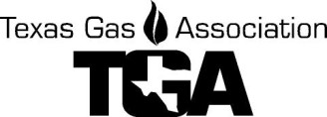
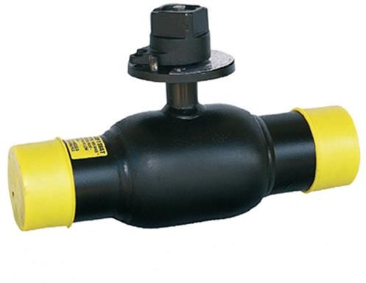
Fundamentals of Valves in
Gas Distribution Systems Cypress, Texas
Tuesday, March 28 2023
9:00 a.m. to 3:00 p.m.
This class will provide the student with the knowledge to understand basic universal valve principles. Attendees will become familiar with Valve Selection, Installation, Operation and Maintenance standards. The student will learn the applicable Federal Regulations, basic techniques for servicing valves under pressure and those in a non-pressurized state. The student will also become familiar with the fittings, tools, and adapters necessary to conduct proper valve installation and maintenance, including reading and interpreting the pressure gauge.

Instructor: Scott McCracken of Balon Valves
We are proud to have Mr. Scott McCracken with Balon Valves as our subject matter expert. Students will benefit from his over 45 years of experience working in the natural gas industry. Our instructor has a background in plug valves, check valves, safety relief valves, floating ball valves, trunnion ball valves, needle valves, regulators and gas measurement. Since Mr. McCracken has worked with a wide variety of valves and been in the industry a considerable time, he has personal knowledge of the continuously improving best practices of the natural gas industry. Additionally, he’s experienced compliance requirements become more stringent.

Where: Si Energy, 21261 FM 529, Cypress, TX 77433

Fee: TGA Members - $50 per person. Non-members - $85 per person. Lunch included!

**Return this class registration form with payment to the TGA Office
E-mail to mail@texasgas.com or by US Mail to PO Box 420960, Houston, TX 77242-0960

Registrant(s) Company
Co. Address City, ST, ZIP Office Phone Cell Phone:
For Check request - Person to receive invoice:

Name: Email:

All card information is required for processing.
Credit Card #

Exp. Date Sec Code

CC Billing Address: City, St, Zip Name on Card
E-mail for receipt , Name PH#

For more information, call Linda Femal or Darrell Cherry at (281) 497-TGAS (8427)
Cancellations received 5 days or more prior to the class date are eligible to receive a refund less a $10.00 processing fee or have the full dollar value kept as a credit on the TGA account to be used by the end of the calendar year. Cancellations received less than 5 days before the event day are not refundable. Substitute Attendees will be accepted for the class.

