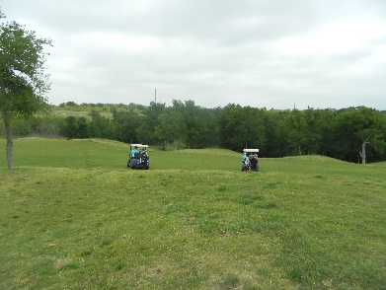
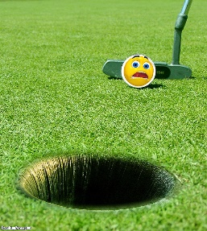
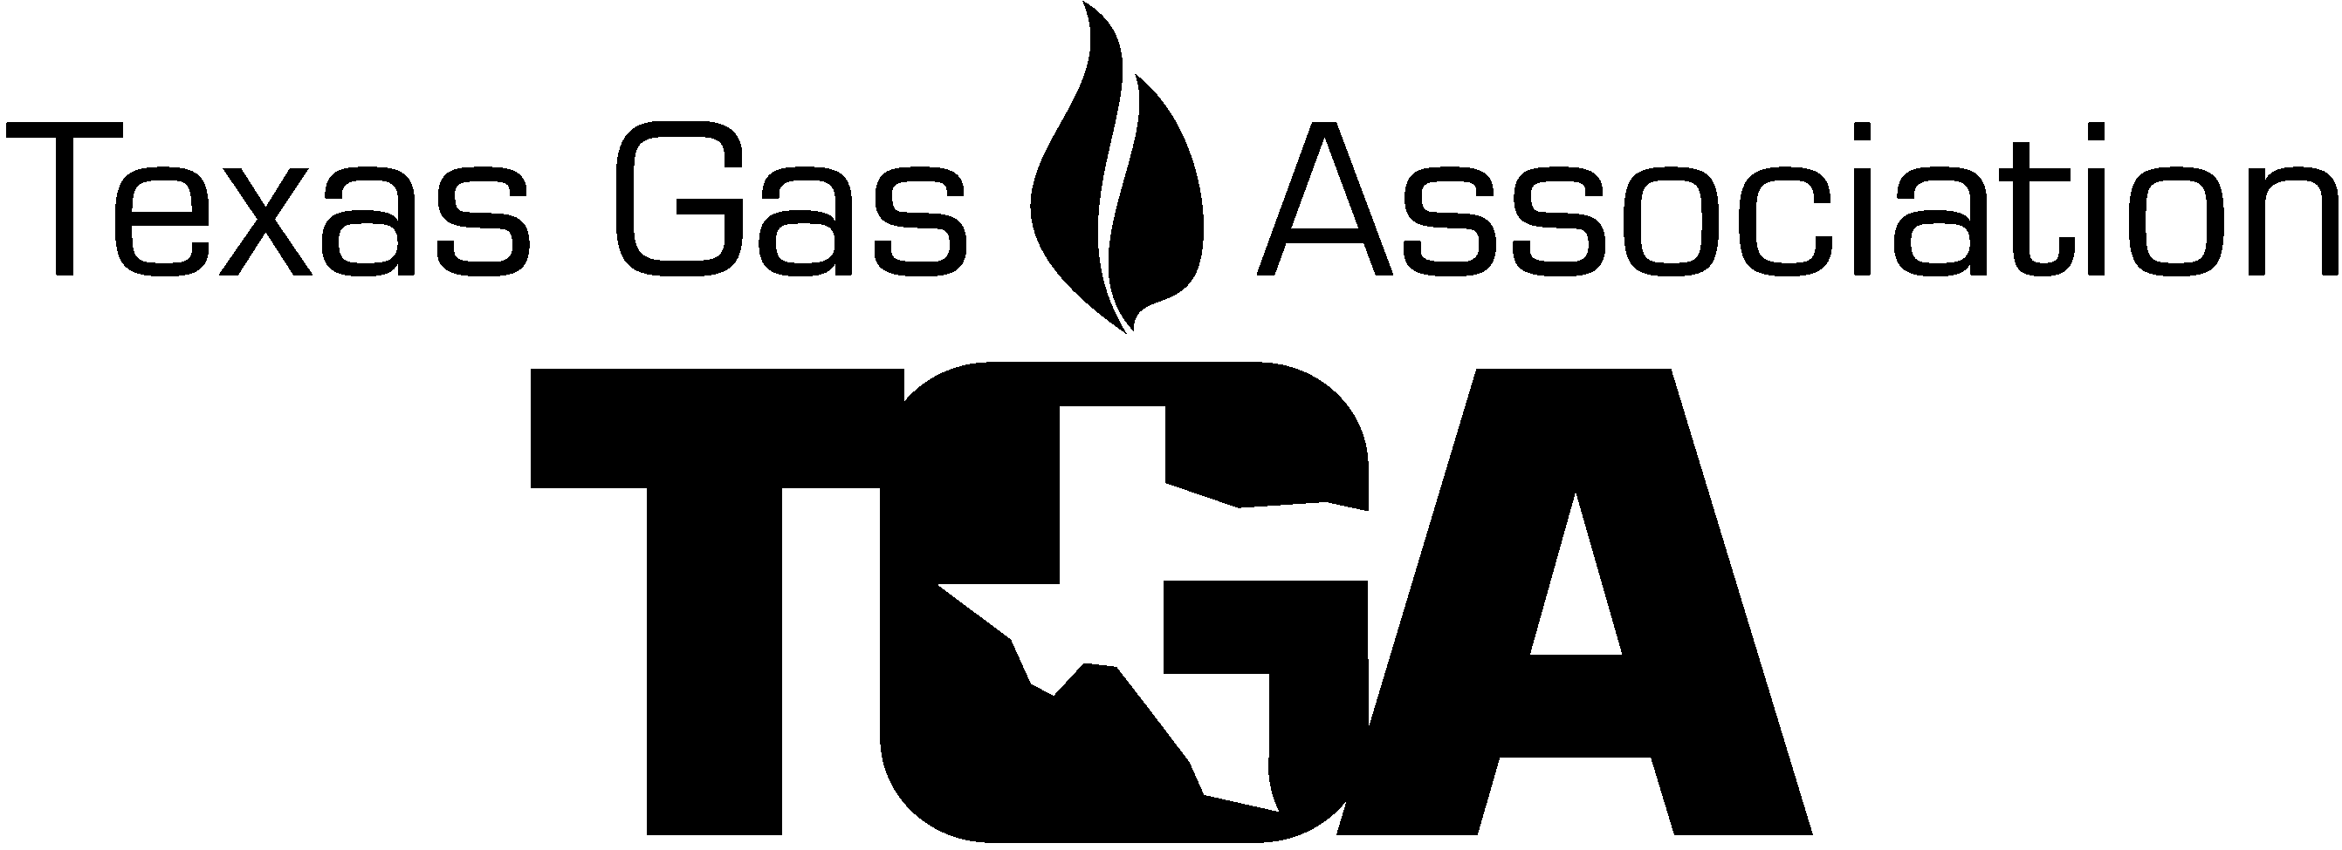

Sponsorship Opportunity!

Support a

Golf Hole / Golf Tee

Advertise your Company!

“LET CLIENTS KNOW WHO YOU ARE”

PURCHASE A GOLF TEE / HOLE OR TWO FOR $125 EACH

With EACH hole sponsored, you will receive your name on a large Golf Ball Sign placed on a golf tee/hole for all to see.

** I WOULD LIKE TO SPONSOR A GOLF HOLE/TEE @ $125.00each X_______ = $__________.

Name Printed Or Logo on Sign(s): ________________________________________________
(If using a logo, email a high-quality logo to mail@texasgas.com in a jpeg format)

Person Responsible: ___________________________________

Address: ______________________________________City: _______________State:________

Phone: __________________ Fax: ________________ Cell: ______________

E-mail Address:_____________________________

_______Check enclosed OR please charge total amount to my:

MasterCard_______ Visa_______ AMX________ Discover _______

Credit Card # _____ _____ _____ ____Exp. Date ________ Sec Code _____ (AMX 4 digits on front)

CC Billing Address: ___________________________ City, St, Zip __________

Name on Card ____________________

E-mail for receipt_________________________ Name ____________ PH# ____________

Total $ __________

