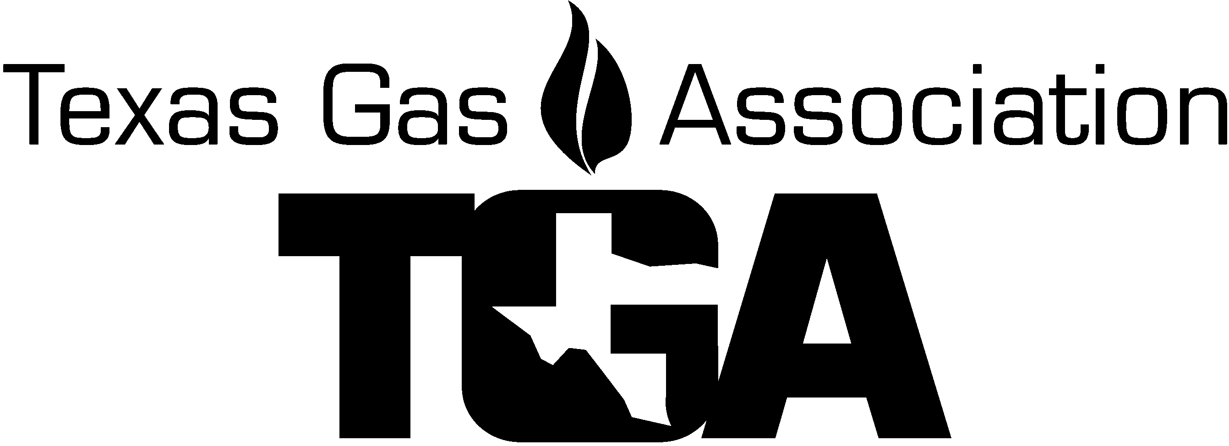
2022 TGA Transmission and Gathering Roundtable

Join us for the 2022 Transmission Roundtable! The roundtable is returning to the San Antonio Riverwalk. The roundtable will provide information for all transmission professionals, seasoned and newcomers. This gathering of the best minds in the industry encourages discussions on the current state and federal regulations and allows for personal exchange of information on industry practices, what is being done and why it works.

Agenda - Subject to Change

Thursday – November 17, 2022
7:00 – 7:30 – Exhibit setup
7:30 – 8:00 – Coffee / Beverage Break
8:00 – 8:10 – Welcome to Transmission Roundtable – Tim Kocian/Darrell Cherry
8:10 – 8:30 – Welcome from the TGA – Paul Kennedy, Si Energy, TGA Chairman
8:30 – 9:15 – “ZeVac Vacuum and Compression” - Bobby Franklin and Roxy Mounter – ZeVac
9:15 – 9:30 – Associate Member Spotlight and Networking Break
9:30 – 10:15 – “Premia Software and Artificial Intelligence for TIMP” - Pankaj Tandon, Praemia
10:15 – 11:00 – “How Magnetism Effects Welders” – Brandon Porter, Industrial Degauss
11:00 – 11:15 – Associate Member Spotlight and Networking Break
11:15 – 12:30 – Lunch
12:30 – 1:15 – “PHMSA Mega Rile, Part 2/Gathering” - Chris McLaren, PHMSA
1:15 – 1:30 – Associate Member Spotlight and Networking Break
1:30 – 2:15 – “Valve Rule/Rupture Detection” – Chris Foley, RCP
2:15 – 2:45 – Open Discussion
2:45 – 3:00 – Associate Member Spotlight and Networking Break
2:45 – 3:00 – Refreshment Break
3:00 – 3:45 – “Remote Leak Detection” - Heath Consultants
3:45 – 4:30 – “Critical Infrastructure” - Jared Ware, RRC
4:30 – 4:40 – Closing Remarks

Friday – November 18, 2022
7:30 – 8:00 – Coffee / Beverage Break
8:00 – 8:10 – Welcome Back – Tim Kocian
8:10 – 8:50 – “Investing in the Generational Workforce” - Clinton Hicks, EWN - Energy Worldnet
8:50 – 9:30 – “PHMSA Update” - Chris McLaren, PHMSA
9:30 – 9:45 – Associate Member Spotlight and Networking Break
9:45 – 10:45 - “RRC update, Gathering Rules Update” - Stephanie Weidman, RRC
10:45 – 11:30 Closing remarks
11:30 – 12:00 Followed by Exhibit Teardown

Reserve your room today!

Embassy Suites, Riverwalk
125 E. Houston St.
San Antonio, TX 78205

Hotel Registration Deadline:

You must make your reservation by the Cut-off Date of Friday, November 4, 2022 or while the rooms last. to receive the TGA Rate of $179++ single or double. Ask for “Texas Gas Association Transmission Roundtable” when making reservations.to make Reservations: Call 1-800-362-2779 and ask for TGA Rate

2022 TGA Transmission Roundtable REGISTRATION FORM

Company ________ Attendee Name ________

Co. Address ____________________ City, State, Zip -

Phone _________ Cell Phone _______________________ Fax __________________
E-mail _____________________________ Spouses Name if attending Lunch ________________________

Transmission Attendee: Member $220.00 ……………………… $________
Transmission Attendee: Non-Member $270.00……………………... $________
Exhibit Tabletop (including one person): Member $390.00…………….. $________
Exhibit Tabletop (including one person): Non-Member $425.00……. $________
Additional Exhibit Personnel: Member $220.00……………………….. $________
Additional Exhibit Personnel: Non-Member $270.00………………….. $________
Additional Lunch for Spouse: Thursday $60.00………………………. $________
** My Company would like to sponsor this event with a donation of: …..$________
(Please e-mail a high-resolution jpeg or tiff file of the company logo to mail@texasgas.com )
You may choose to use the sponsor form for separate transaction if you prefer.
Total Due $________
To help reduce the overspending, this questionnaire is to help us prepare more accurately for the food preparation and services needed.

Will you be attending? Please indicate the number of people attending.

Thursday’s Luncheon at the hotel? YES or NO

Please return completed form along with payment to:

Texas Gas Association
P.O. Box 420960
Houston, Texas 77242-0960
Phone: 281-497-TGAS (8427)

E-mail mail@texasgas.com

Check payable to TGA enclosed Charge my ______AMX, ______Master card, or ___ Visa

Credit Card # ____ _____ _____ ____ Exp. date ____ Sec Code _____ (4 digits on front AMX)

CC Billing Address ______________________________ City, St, Zip code ____________

Name on card ___________________

E-mail for receipt: ____________________, Name ____________PH# _______________

Topic(s) I would like to discuss:
Topic: __________________________________________
Question ______________________________________________

Cancellation for Roundtable Seminar must be in writing. Cancellations 30 days plus prior to seminar: Full refund less $30.00 processing fee. Cancellations 11-29 days prior to conference: Refund half of Seminar event charges. Cancellations less than 10 days prior to conference: will not be refunded. No-shows: will not be refunded. Substitute Attendees will be accepted.

