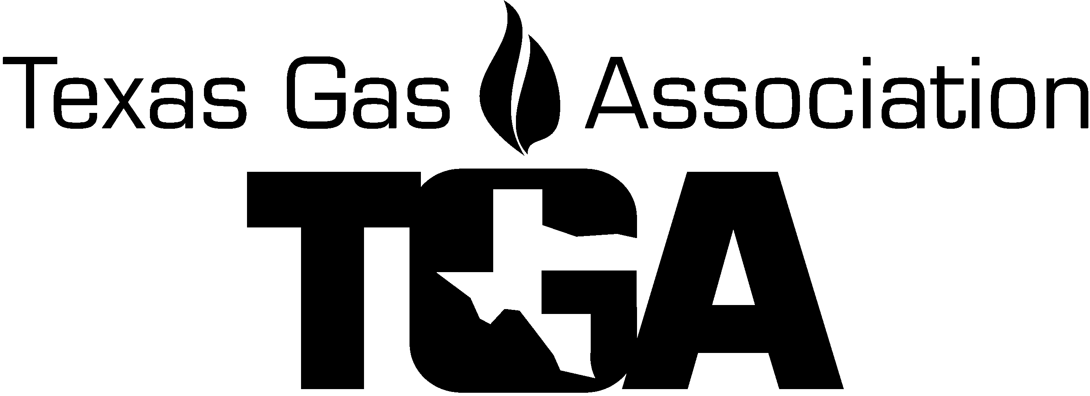

PO Box 420960, Houston, TX 77242-0960 / Phone 281.497.8427 / E-mail: mail@texasgas.com

2022 Gas Transmission & Gathering Roundtable

“Sponsorship Form”

Embassy Suites Riverwalk

125 E. Houston St.

San Antonio, TX 78205

November 17 -18, 2022

Name on Signage: ___________________________________
Person Responsible ______________________________________
Co. Street Address __________________________City, State & Zip Code_____________
Telephone Number __________________ Fax __________________

E-mail Address___________________________________________________________

For a successful event, please help support the
Transmission Roundtable by sponsoring:

Overall Conference Sponsorship $_______

Wednesday to Friday, November 17-18, 2022

Make checks payable to: Send credit card information to:
TGA / Texas Gas Association E-mail: mail@texasgas.com
Texas Gas Association
P.O. Box 420960
Houston, TX 77242-0960 We Accept: American Express, Visa & Master Card

CC#:_______ ________ ________ _________ Exp Date: ________ Sec Code _____ (AMX 4 digits on front)

CC Billing Address ________________________________ City, St, Zip ________

Name on Card: ________________________________ Total Amount Due $ _________

E-mail for receipt: _______________________________ Name_____________ PH# ____________

FOR RECOGNITION:
Please email a high-resolution Company Logo in a jpeg or PDF format to the TGA Office that can be enlarged without distortion to mail@texasgas.com as soon as possible. Thank you.

