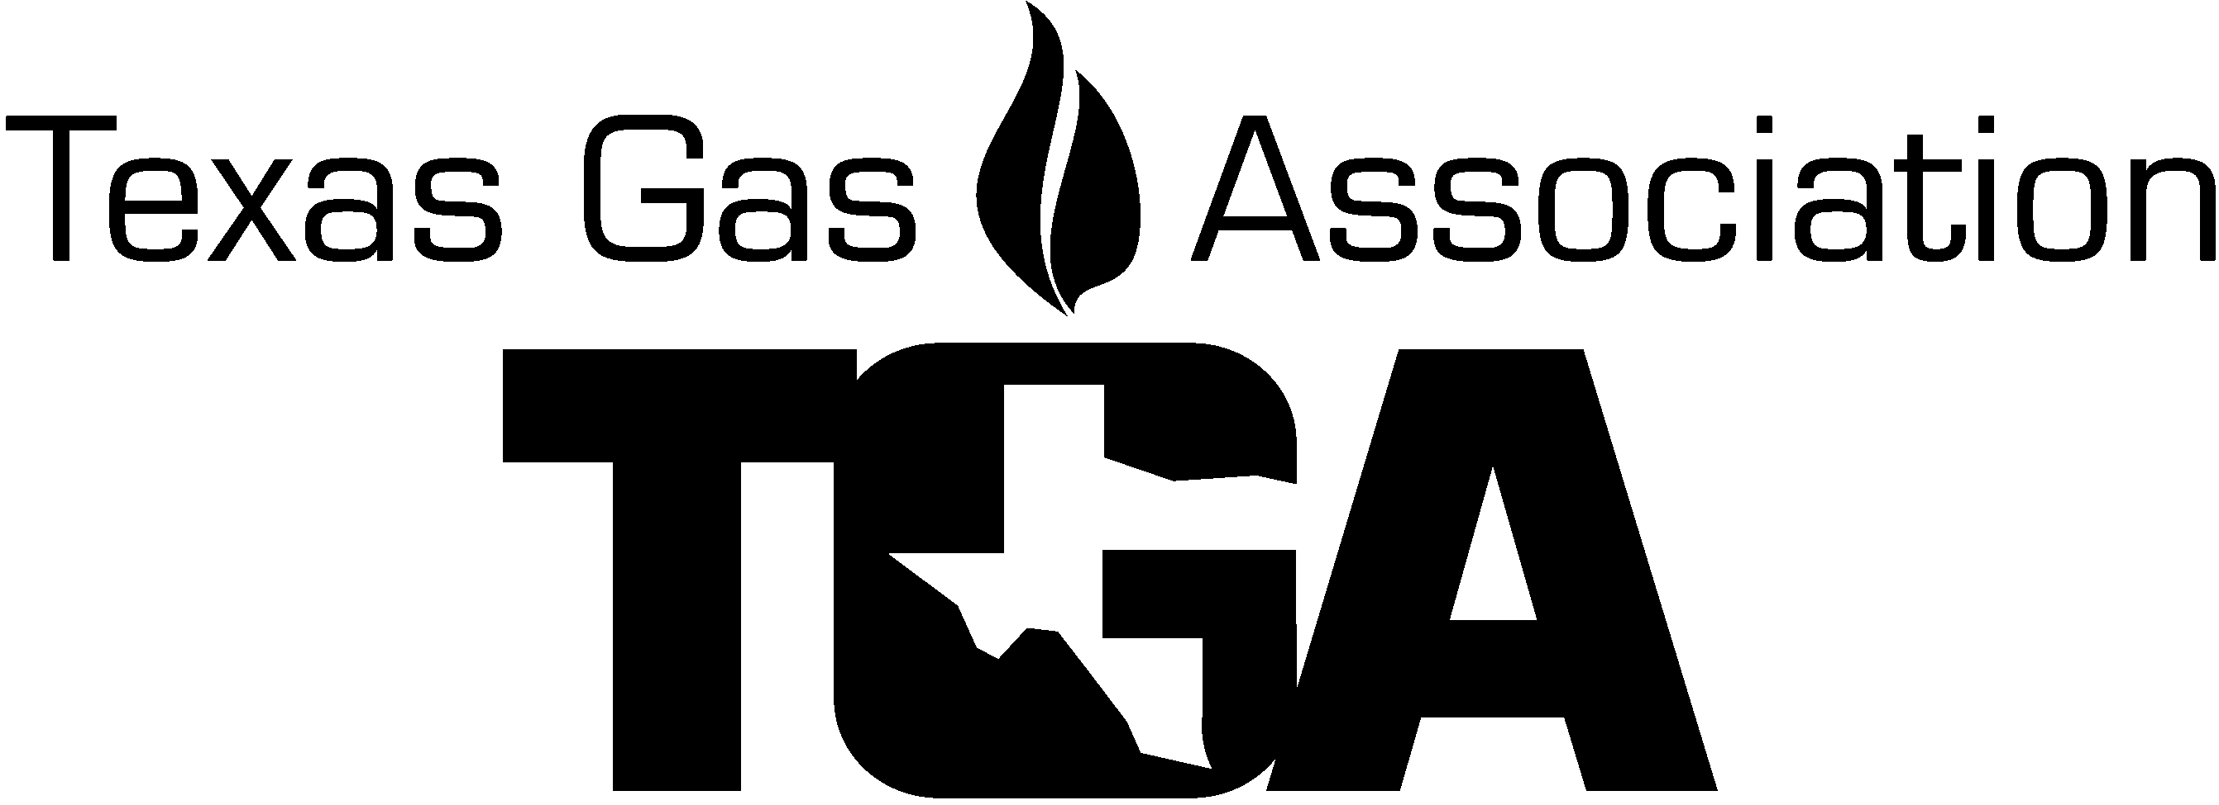
2022 TGA Damage Prevention & Safety Roundtable
Registration Materials

Join us for the 2022 Damage Prevention and Safety Roundtable! The roundtable this year is in New Braunfels, TX at the New Braunfels Civic Conference Center at 375 S. Castell Ave., New Braunfels, 78130. The roundtable will provide information for all damage prevention and safety professionals and any other gas company employees. This gathering of the best minds in the industry encourages discussions on the current state and federal regulations and allows for face-to-face exchange of information and ideas on industry best practices, what works and what doesn’t.

Meeting Agenda

(Subject to Change)
Wednesday, September 7, 2022
7:30 – 8:00 am Exhibit setup
8:00 – 9:00 am Exhibits Open
8:00 - 9:00 am Registration & Continental Breakfast
9:00 – 9:50 am Safety Culture - Culture is Everything - James Cross and Kelsey Klingler, Energy worldnet
9:50 - 10:40 am Wildland Fire – Tina Sanders, Texas 811
10:40 – 10:45 am Product Showcase Presentations – (3 - 1.5 minute)
10:45 – 11:35 am DOT – Roadway Safety
11:35 – 12:00 pm Exhibits Open
12:00 - 1:00 pm Lunch – Catering Bill Miller BBQ
1:00 - 1:50 pm Watch and Protect w/WSB – Nate Osterberg, WSB Engineering and
James Steck, CenterPoint Energy
1:50 – 2:40 pm OSHA – Avoiding Being Struck by Incidents - Joann Natarajan, OSHA
2:40 – 2:45 pm Product Showcase Presentations – (3 - 1.5 minute)
2:45 – 3:00 pm Refreshment Break & Exhibits Open
3:00 – 3:50 pm Damage Analytics, The Industry Standard – Case Wells, Texas 811
4:00 pm Meeting Closed
6:00 pm Dinner – Location TBD

Thursday, September 8, 2022
8:00 – 9:00 am Exhibits Open
8:00 – 9:00 am Continental Breakfast
9:00 - 9:50 am Fire Department of New Braunfels
9:50 – 10:00 am Exhibits Open
10:00 – 11:00 am Pre-excavation checklist – Derrell Isenberg, Binkley & Barfield
11:00 am End of Meeting

Topics I would like to discuss:

Topic ___________________________________________________________________________________
Question ______________________________________________________________________________________________________
________________________________________________________________________________________

Final Registration date is August 26th

Please see list for hotels near the New Braunfels Civic Convention Center

2022 TGA Damage Prevention & Safety Roundtable

Early REGISTRATION FORM

(Please, One Registrant per form)

Company ________ Attendee Name ________________________________

Co. Address ____________________ City, State, Zip -

Phone _____________________________ Cell Phone ______________________________
E-mail: ______________________________________________ Spouse’s Name (if attending) _____________________

Registration | Amount | Price
TGA Member Attendee Registration Paid After Friday, 8/5/2022 | $245.00
Non TGA Member Attendee Registration Paid After Friday, 8/5/2022 | $295.00
Spouses Lunch & Dinner
Spouses Lunch | $50.00
Spouses Dinner | $70.00
Exhibit Tabletop & Additional Exhibitors
TGA Member Tabletop – includes 1 person Paid After Friday, 8/5/2022 | $350.00
Non TGA Member Tabletop – includes 1 person Paid After Friday, 8/5/2022 | $400.00
TGA Member Additional Exhibit Personnel Paid After Friday, 8/5/2022 | $245.00
Non TGA Member Additional Exhibit Personnel Paid After Friday, 8/5/2022 | $295.00
Final Registration date is August 26th
No registrations will be accepted after this date! TOTAL DUE

Please answer questions below. Will you be attending?
- Wednesday’s Lunch? Yes or No
- Wednesday’s Dinner? Yes or No

Check payable to TGA enclosed Charge my ______AMX, ______Master card, or ___ Visa

Credit Card # _________ __________ __________ __________ Exp. date _______ Sec Code ______ (AMX 4 digits)

CC Billing Address _____________________________________________ City, St, Zip code ________________________

Name on card ____________________________

E-mail for receipt: __________________________________________, Name _________________PH# ________________

Cancellation for Roundtable Seminar must be in writing. Cancellations 30 days plus prior to seminar: Full refund less $30.00 processing fee. Cancellations 11-29 days prior to conference: Refund half of Seminar event charges. Cancellations less than 10 days prior to conference: will not be refunded. No-shows: will not be refunded
Substitute Attendees will be accepted.

